**Day-5. Assignment**

**1.** Write a program that reads a file named "input.txt" and writes all lines containing the word "error" to a file named "error_log.txt". Then, read the "error_log.txt" file and print the contents to the console.

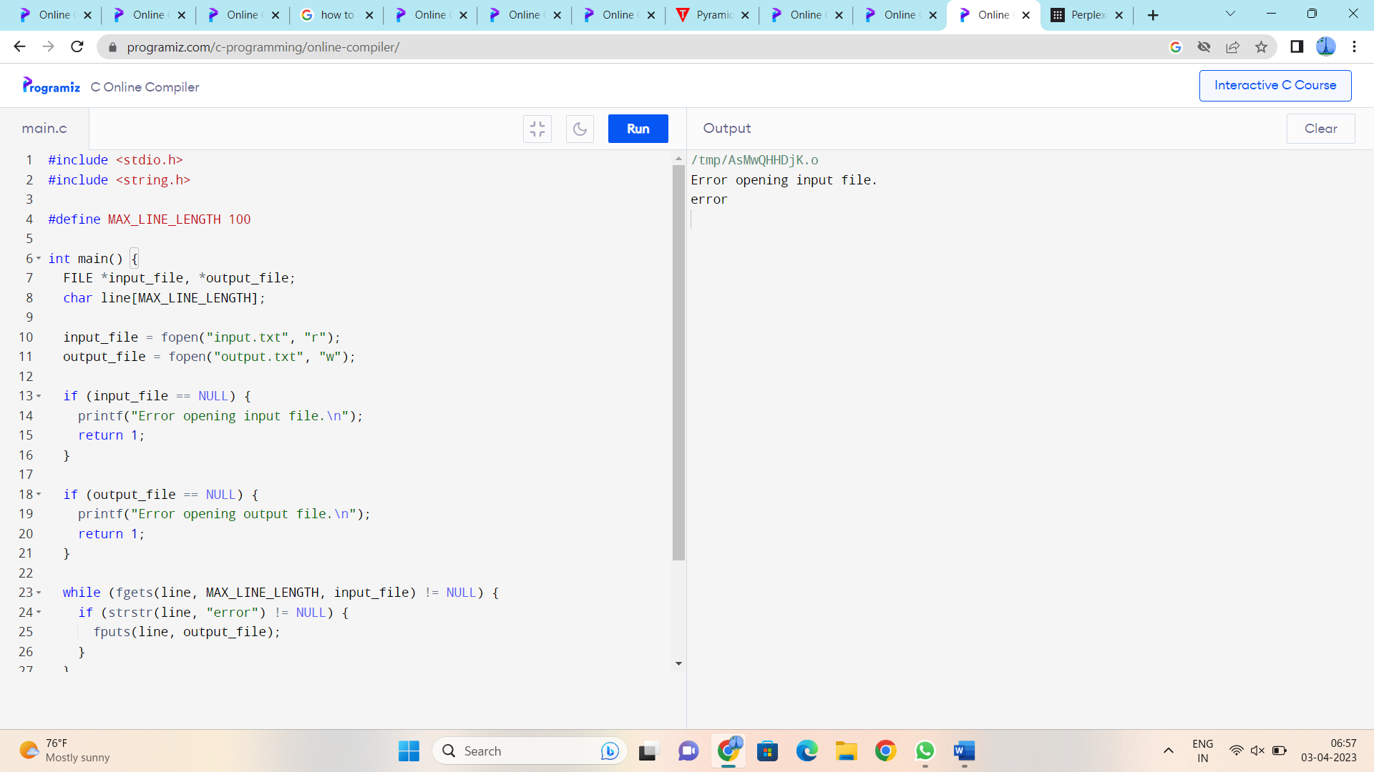

**2.** Create a program that reads data from a binary file named "data.bin" and prints it to the console in a human-readable format.

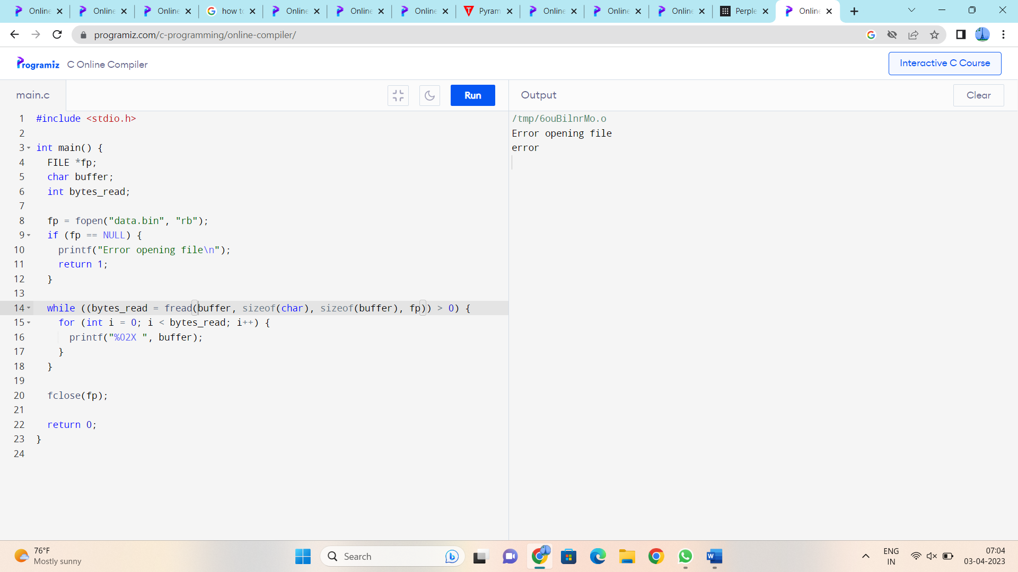

**3.** Write a program that reads a text file named "input.txt" and replaces all occurrences of the word "red" with the word "blue". Then, write the modified text to a new file named "output.txt".

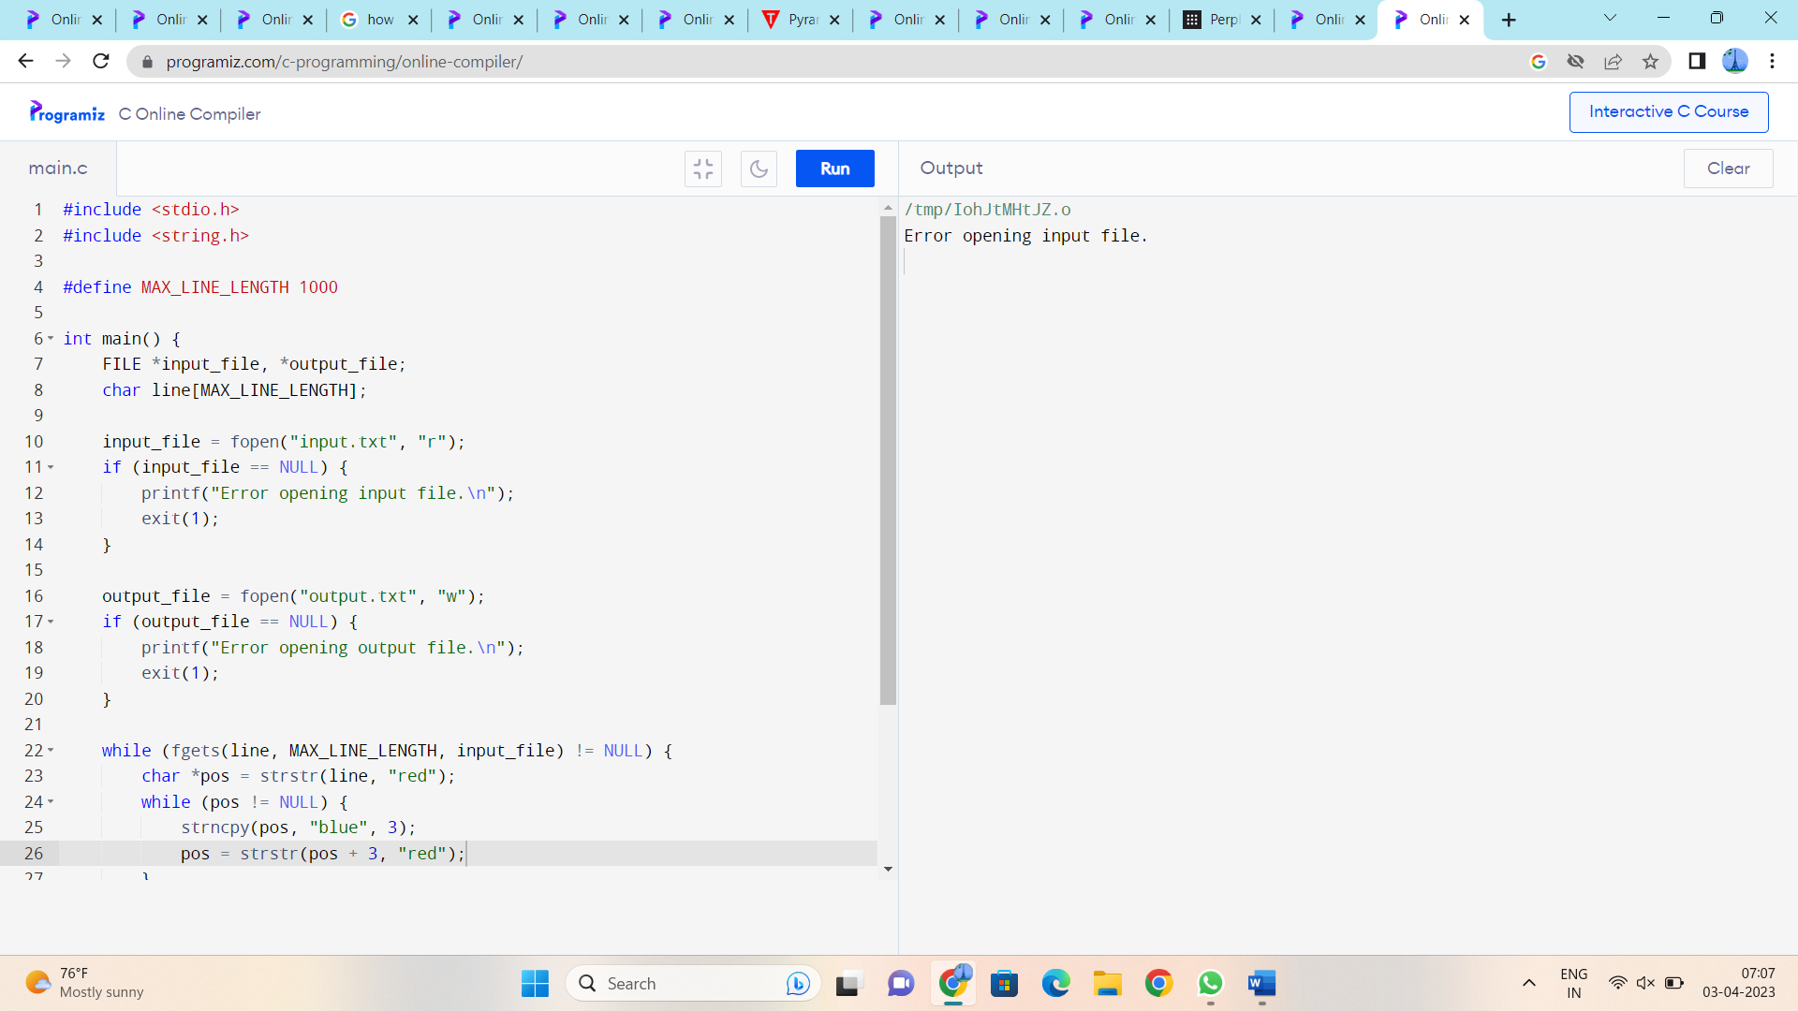

**4.** Create a program that prompts the user to enter the name of a file and a search string. The program should read the file and print all lines that contain the search string to the console.

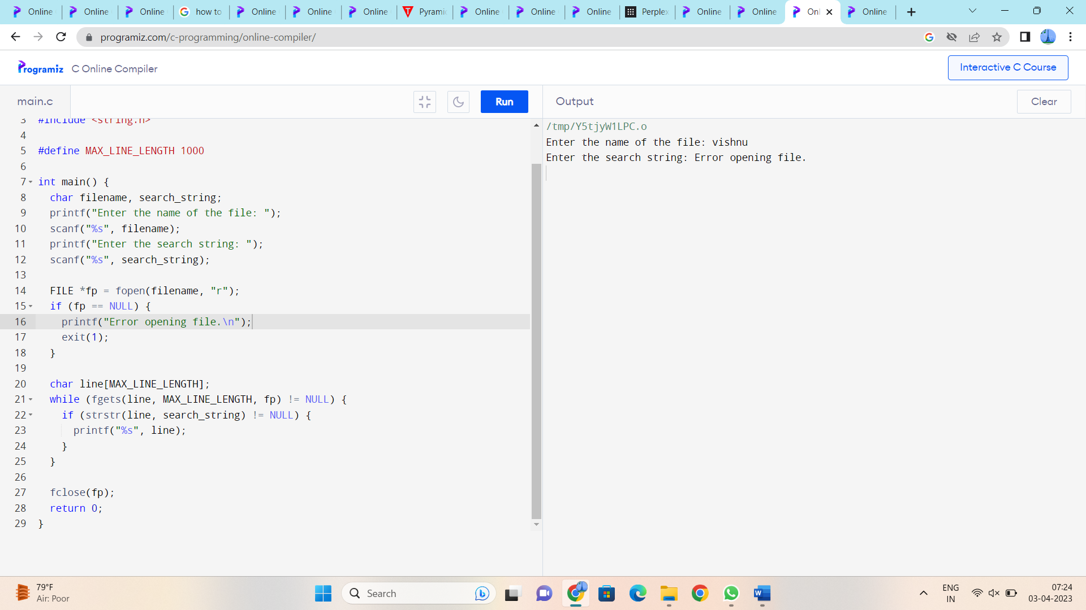

**5.** Write a program that reads a file named "data.txt" and creates a new file named "statistics.txt". The program should write the number of occurrences of each letter of the alphabet in the file to the "statistics.txt" file.

